THE USE OF INFORMATION TECHNOLOGY IN A BUSINESS: COLUMBUS STAINLESS’ LEVEL 3 INFORMATION TECHNOLOGY P6 DEPARTMENT

ITRW 225 Systems Analysis and Design II

Barnard, A. P. 28430093

1. INTRODUCTION AND INFORMATION ABOUT THE BUSINESS
Columbus Stainless Steel was founded in South Africa, Mpumalanga-Middelburg in 1966 to be the only company in Africa to produce stainless steel flat products. Acerinox (Spain) is the parent company for producing owning 76 % of Columbus Stainless shares with the rest of the 24 % share balance held by the IDC (Industrial Development Corporation). Columbus is part of the Acerinox group of companies together with North American Stainless (NAS), Bahru Stainless in Bahru, Malaysia and Acerinox in Palmones, Spain.
Columbus Stainless is a technologically advanced and fully integrated production company and its single-site operation gives it the advantage of quick adjustment flexibility to changes in the market.

Modern stainless steel is produced with a wide range of products in Austenitic, Ferritic, and Duplex grades in various forms and parameters for various applications. At present 25 % of produced products are sold in South Africa and sub-Saharan market, exported products are channelled through a well-developed network of agents and group sales outlets operating in Europe, the Americas, the Middle East and the Far East.

Austenitic steel, is used to manufacture knives and forks; Ferritic steel, which is a magnetic type of steel is used in industry-specific machines; and finally, 3CR12 type steel, which hardens on impact, is rust resistant and low on cost. These products are manufactured according to customers’ specifications in sheets, coils, slabs or plates.

There are five levels in Columbus: LØ Thermocouple systems; L1 Instrumentation systems; L2 Plant systems; L3 Business systems and the P6 department; L4 Business supporting systems, Human Resources and Financial systems (Hart, 2018a).
Columbus' levels and the production line is shown below. (Hart, 2018a; Van Staden, 2018)
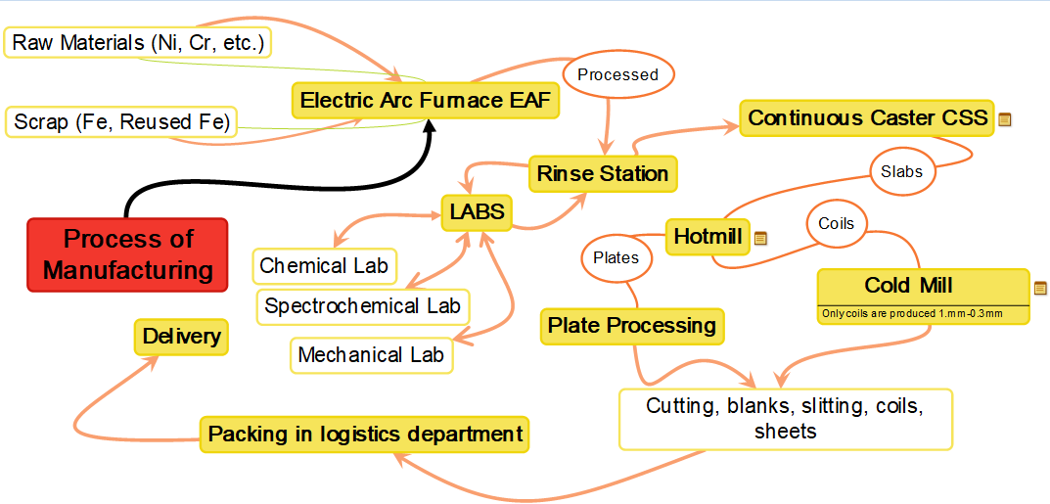
The P6 department of Columbus has a number of information systems. Firstly, Calami Costing. It is responsible for all the maintenance of costing, product prices, currency converting etc. (Hart, 2018a). Secondly, Romax, the raw material management system that is responsible for all the raw material purchases from suppliers to the Columbus facility. It handles invoicing and integrates with Calami Costing for payments and discounting.

Columbus also uses JD Edwards Enterprise Resource Planning (JDE ERP) software created by Oracle (Oracle, 2018). The JDE ERP system is responsible mainly for integrating the financial services with Romax; Capital Asset Management during maintenance purchasing and maintenance of inventory and consumables in Columbus specifically (Van Staden & Hart, 2018).
Just like Calami Costing and Romax, Formatos is also in-house software that Columbus uses and was created by the Acerinox group of companies (Hart, 2018b). Formatos is a customer specifications management system that the Acerinox group uses that is in constant synchronization with the MAX Sales system (see below). Formatos manages extremely detailed information for every customer. Each byte of data is used by a different department to ensure that the product is delivered to the exact specifications of the customer – and where millimetres can cost hundreds of thousands of rand.

MAX Sales system is where all orders start. Their specifications go to Formatos, the ordering data go to the LOTS system (see later) where the path to production, production duration and other relevant information is stored and made accessible to the other departments.

LOTS is a system that Columbus uses for its scheduling and feedback operations. LOTS uses a manufacturing execution system (MES) called a CMV, that communicates and shares data with the second level, L2, which delivers specifications to the Plant systems as a messaging database. The purpose of the LOTS system is to see what parts of the production route can be grouped with others during the business rule engine process (Hart, 2018a). This is important to improve efficiency and reduce the cost to the company.
LOTS integrates with the business rules engine, called Corticon. Corticon empowers Columbus to divide the departments’ production lines into small pieces (Progress Sitefinity, 2018). It then looks at products in the production line and orders the process parts to improve efficiency, e.g.

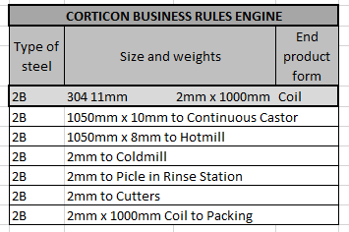
Corticon uses XML (eXtensive Markup Language) files with all necessary product information in a programming language Corticon can use (W3Schools, 1999).
Corticon integrates with the logistics department of Columbus. The logistics department is responsible for trucking needs and scheduled routing of vessels, returns on products and manages the warehouses (Hart, 2018b). From there the completed products go to the shipping areas and are shipped by truck or chartered vessel to Bahru and internationally.
Along with Calami Costing, MAX Sales, Romax, Formatos and LOTS, Columbus uses the JDE ERP system to create custom software for the business that integrates with IBM systems that run their entire backup facilities.
Below is a summary of the above processes: (Hart, 2018b; Van Staden, 2018)
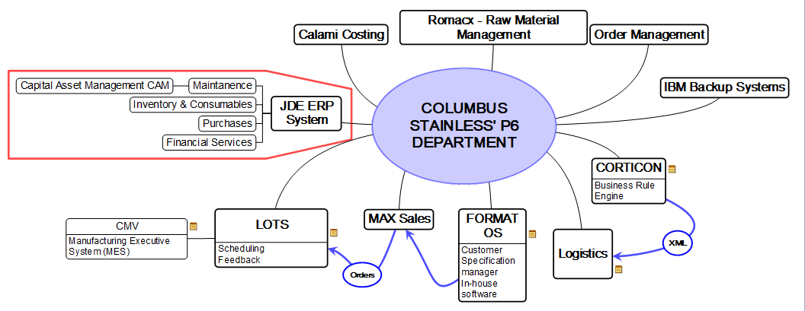
2. IMPORTANT CONCEPTS
2.1 business systems analysis and design
Business systems analysis and design consist of two problem-solving techniques. The first technique, systems analysis, breaks a system down into its base components to establish to what degree the parts work and interact to accomplish their goals. It also studies the problem areas of the business to propose solutions. The second problem-solving technique, systems design, is complementary to systems analysis in that it reassembles these parts into a complete working system – but an improved version thereof, which is the goal of using analysis and design. (Bentley & Whitten, 2007:743-744).
2.2 feasible solutions/cost-effective solutions and problem solving
Feasible solutions can be best described by breaking the two components down into pieces. Firstly, feasibility is a measure of how beneficial or practical the system would be to an organization. A solution is simply the answer to a problem, a fix to an error or another way to correct to a new whole. Thus, a feasible cost-effective solution is the answer to a problem that is both beneficial and practically attainable, but also it needs to strike a balance between the lifetime costs (i.e. development costs, maintenance costs and operating costs), and the benefits of using this solution for the company. (Bentley & Whitten, 2007:724-729).
Problem-solving consists of finding ways to get a solution or a fix for an error or irregularity. This can involve using methodologies or approaches like A3, OOOA, SMART etc. This can also entail using approaches from other disciplines like engineering, psychology, cognitive sciences and asking the MOM system.
2.3 interpersonal skills, e.g. communication skills
According to the Oxford dictionary (2018), interpersonal skills can be defined as “The ability to communicate or interact well with other people”. Communication skills refer to the ability to share thoughts, feelings and information with others whilst accurately conveying the facts or information. Thus, in an information technology sense, interpersonal skills refer to how well a person can convey information to another on a level that they can understand, whilst still maintaining the accuracy of the information and professionality. Interpersonal skills directly correlate with communication skills, because one cannot effectively communicate if one does not understand social cues e.g. eye-contact, shaking hands, looking at the speaker etc.
2.4 software development/software engineering
Software development is the process of creating software in sequential phases or parts to the specifications of the objectives of the project. Software development does not only entail computerised solutions but also entails physically writing code and planning the parts of the design (Rouse, 2018a).
Software engineering is when engineering principles are applied to physical systems and to the design, deployment and management phases or aspects of the system (Rouse, 2018b). This principle combines both disciplines to create a better system than the disciplines could when used apart.

3. ASPECTS OF THE INFORMATION SYSTEMS IN COLUMBUS STAINLESS’ P6 DEPARTMENT

3.1 types of information systems
Columbus uses an Office Automation System (OAS) called the CMV. This allows the users to create and share documents, hyperlinks and other relevant information with other users and management. The advantage thereof is that other users will be able to search for a solution to a problem already discussed and solved previously. This allows the IT department to free up more time to work on other solutions, whilst the user can solve the problem with the help given in the CMV solution file.

Calami Costing, Columbus’ cost maintenance system is a Transaction Processing System (TPS), and this allows the company to do complex billing and costing transactions almost instantly from all over the world, and thus removing the human error possibility. The TPS allows users to also print detailed reports showing all transactions, earnings, billings and all other financial information within seconds.

A greatly detailed example of a Decision Support System (DSS) is the Formatos system and Corticon business rule engine. A decision support system’s main goal is to choose between multiple options and use its pre-coded what-if analysis tools to choose the best process for the materials to go through (Riley, 2018).

The MAX Sales system can be viewed as a Management Information System (MIS) in particular for its functions that allow executives and managers to view business processes as a whole or in parts. This enables them to thus make business informed decisions that will ultimately impact the entire company.

3.2 information systems development methodologies used to implement information systems in the business
The information systems development methodologies used in Columbus resemble that of figure 3-9 of Jeffrey Whitten and Lonnie Bentley’s book System Analysis and Design Methods (Bentley & Whitten, 2007:93). This figure shows a movement called agile methods that suggest that development methodologies should combine other methodological strategies e.g. custom building or buying software, following adaptive or prescriptive rules, being product or model-driven etc.

Columbus combines different methodological approaches to create a successful agile system. This system uses bought solutions, like the JDE ERP system, and also has software that was custom built in-house, e.g. Calami Costing, Max Sales, Formatos etc.

This system also follows a model-driven methodological approach, wherein all new software and models should be object-oriented models whilst still lending functionality to old prototypical software.

Columbus system of development also follows an iterative approach. This means that the development methodology it implemented to every iteration over and over in order for the iterations to, together, form one complete system.

3.3 project management approaches
The project development approaches used by Columbus also follows an agile methodology, as explained by EP de Lange in The use and effectiveness of project management methodologies in mobile application development (De Lange, 2015). Herein, De Lange notes that an agile project management methodology has many key features like a continuous design, flexible scope, higher embrace towards change, higher customer interaction etc.

De Lange’s description is almost exactly the way that Columbus approaches their development methodologies. All projects have to have an everchanging functionality to it, in order for it to satisfy the customers' ever-changing needs. In some cases, business decisions were made and implemented that the plant systems could not adhere to for various reasons (e.g. safety matters, production line prerequisites etc.).
It is thus needed that the system is dynamically changeable to some degree without losing functionality in other parts of the system. Their project management approaches do follow the standard sets of approaches, but it adds the dynamic agile component that is needed from the system to deliver a working system and thereby a complete product.

3.4 security used within the IT systems of the business
In terms of physical security, Columbus has electronic gates with identity card access points. Each employee, executive, trainee and guest must have an identity card. The identity cards must be in the visual field at all times and employees must present them whenever asked by security. Guards are posted at each entrance and exit and at regular and random intervals they do supervisory checks.
Employees are not allowed to have laptops or personal computers on the premises of the company to ensure that all data and systems remain safe and secure.
Employees and baggage are searched before exiting the premises.

Columbus also implemented a security protocol across the entire company, that monitors all internet and intranet activity of the employees. Bandwidth and download limits are implemented according to policy. Strict and secure firewalls are installed on every workstation and are updated automatically. Patches and software issues are addressed immediately and implemented company-wide.

All servers remain in an air-locked room only accessible by high-level employees. All server rooms are air locked with CO² seals to prevent fires. False floors were installed as an extra measure of security. Server cabinets are also bolted to walls and concrete floors. All systems are tested weekly and/or monthly by means of evacuations, drills and other security means.
All of the above measures are taken to prevent employees from gaining access to restricted areas of the business or from seeing, sending or otherwise sharing company software and/or data. This is how Columbus has maintained their leak-free status for the last 50 years.

Columbus also does not store any data on a cloud or over the internet to ensure that their systems stay secure. In the past, Pakistani hackers have tried to gain access to Columbus systems but were met with dummy values and an extra layer of security in the form of an expert system that analyses all data for irregularities.

3.5 backup strategy for information systems and data
Columbus uses a MIMIX system in real time as their primary backup. This system updates all information to three separate locations to ensure minimal data loss in case of an emergency. Columbus also uses additional servers that are completely air-gapped and separate from the main servers. Each workstation is also fitted with a UPS (Uninterruptible Power Supply) in case of power outages.

Columbus bought three new servers to the value of above R3 million each. They have liquid cooling systems and are made up almost entirely of SSD drives, which is the fastest technology currently available. These servers also run virtual software that virtually duplicates or triplicates the storage space.

Some lower level employees were also fitted with client servers that connect to the main servers via the internet, without the employee requiring the additional RAM or storage space that a personal computer requires.

Backups on the MIMIX system is additionally run weekly, incrementally with a two week rollback period. Offline servers are backed up fully on weekends. Also, all systems are automatically fully backed up every month and these records are kept indefinitely.
The entire company’s workstations, approximately 5000 workstations, are backed up within three hours thanks to the new servers and virtual software.

3.6 the use of social media in the business
Columbus has a website that describes all processes and information that consumers need to know. Currently, Columbus cannot afford to implement a feature to order products online due to the sensitive nature of some data and due to the accuracy that is required for all the systems to work. A website ordering system would however not be sufficient for the customer, and it would definitely not be sufficient for the software that needs to use these data values.

Columbus has a Facebook page that people can comment on and check in to, and where announcements of good tidings and positive reports are posted.

4. IS/IT ARCHITECTURAL ASPECTS IN COLUMBUS STAINLESS’ P6 DEPARTMENT
My view on certain aspects below was limited because of privacy and security concerns of the company.

A cross-functional information system is an information system that supports the processes of the business but ignores traditional organizational boundaries and specifications like divisions, areas and departments (Bentley & Whitten, 2007:53). Columbus sports a cross-functional information system from the expert systems that they have created and implemented that work across departments and divisions regardless of their areas or locations.

Columbus systems use the clean layering approach to replace existing software and business areas with others without negatively impacting the other systems (Bentley & Whitten, 2007:59).

Columbus uses the Pay-As-You-Go business model where the customer only pays for what they require. All revenue is derived from the product delivery and supplies. Columbus is also part of a Franchise business model, where the Acerinox group of companies is the main franchise supplying Columbus with money and resources like the abovementioned in-house software that is used.

The Calami Costing and MAX Sales systems are great examples of information technology systems that are designed according to business and objectives. Calami Costing and MAX Sales were created primarily to satisfy business needs with regards to shortcomings that the current business software has.

Columbus Stainless, North American Stainless, Bahru Stainless and Acerinox each have multiple sales facilities across the world that serve as their primary sales departments. These departments communicate with their nearest company top supply the product. In some cases, the product is produced at a different facility and chartered to that location.

Columbus also sports one of the biggest databases containing data about customer specifications, financial transactions, business-related data and other information. This is all stored in an Oracle database on every server in all departments. Unfortunately, guests aren’t permitted to know the exact identity of the database system.

Columbus uses client servers for general employees’ workstations. The company implemented thin clients to low usage individuals and fat clients for high usage individuals. Each of the stainless steel companies has transactional, application and database server space on their main servers that are located on the premises (Hart, 2018b).
The internal network of the companies is located on dedicated web servers on the premises also. Each server is also backed up and mimicked by the MIMMIX system.

Regarding networking, Columbus has a dedicated network hub that is rented out to Telkom telecommunications, that is used to supply continuous networking capabilities that Columbus requires. With these network hubs, they have also installed dedicated network servers that supply networking and wireless fidelity (WiFi) capabilities to every workstation in the organization.

5. CONCLUSION
This report serves as a guide and insight into how Columbus Stainless works, and as an indication of my role as an observer thereof. This report aims to show what I have learned from the business environment and tests the knowledge that has been accumulated to date.

The goal is to display a full knowledge of the business environment and of the theoretical aspects and how they are constantly intertwined to form a working structure.

All businesses, especially Columbus is extremely dependent on it's IT department, due to the fact that there are so many different programmes which are used to fulfil the requirements that Columbus has to service its customers and to ensure that a complete and customised product is sent to the customer. If one of these programmes are not functioning properly, it could cause an error when it comes to either costing, production, invoicing or even logistics which could be to the detriment of the company.
- IT personnel are extremely dedicated, and customer orientated.
- - I have learnt that you require interpersonal skills to be able to communicate with customers (employees) and to ensure that all requests are carried out in a professional and business-like manner.
- I have learned how theory is important for a full understanding of a business’ workings, but that actual practice and application may differ from theory in order for it to be a successful system.

The role that I portrayed was an observer of the different departments. I was not permitted to see every aspect of the system due to privacy concerns of the company, but I still managed to get a full well-rounded view of the business environment.

6. BIBLIOGRAPHY
Bentley, LD. & Whitten, JL. 2007. Systems analysis and design for the global enterprise. 7th edition. Boston, MA: McGraw-Hill.
Columbus Stainless (Columbus). 2018. Stainless steel. https://www.columbus.co.za Date of access: 14 Jul. 2018.
De Lange, EP. 2015. The use and effectiveness of project management methodologies in mobile application development. Potchefstroom: NWU. (Dissertation – MSc). NWB 658.404DEL
Hart, H. 2018a. The use of information technology (IT) in a business: Columbus Stainless’ P6 Department [personal interview]. 25 Jun., Middelburg.
Hart, H. 2018b. The use of information technology (IT) in a business: Columbus Stainless’ P6 Department [personal interview]. 26 Jun., Middelburg.
Oracle. 2018. Oracle’s JD Edwards EnterpriseOne. http://www.jdedwardserp.com Date of access: 22 Jul. 2018.
Oxford Living Dictionaries. 2018. Interpersonal skills. https://en.oxforddictionaries.com/definition/interpersonal_skills Date of access: 24 Jul. 2018.
Progress Sitefinity. 2018. Why choose Corticon. https://www.progress.com/corticon Date of access: 22 Jul. 2018.
Riley, J. 2018. ICT: types of information. https://www.tutor2u.net/business/reference/ict-types-of-information Date of access: 24 Jul. 2018.
Rouse, M. 2018a. Learn IT: software development. https://whatis.techtarget.com/reference/Learn-IT-Software-development Date of access: 24 Jul. 2018.
Rouse, M. 2018b. Software engineering. https://whatis.techtarget.com/definition/software-engineering Date of access: 24 Jul. 2018.
Van Staden, M. 2018. The production line of Columbus Stainless [personal interview]. 26 Jun., Middelburg.
Van Staden, M. & Hart, H. 2018. The use of information technology (IT) in a business: Columbus Stainless’ P6 Department [personal interview]. 26 Jun., Middelburg.
W3Schools. 1999. Introduction to XML. https://www.w3schools.com/xml/xml_whatis.asp Date of access: 22 Jul. 2018.

